Final Project Worksheet

1. GitHub Pages Link

https://antiguamaximo.github.io/CST2309Final_Project/

1. Add screenshot of **Page 1 About Us page** displayed in browser

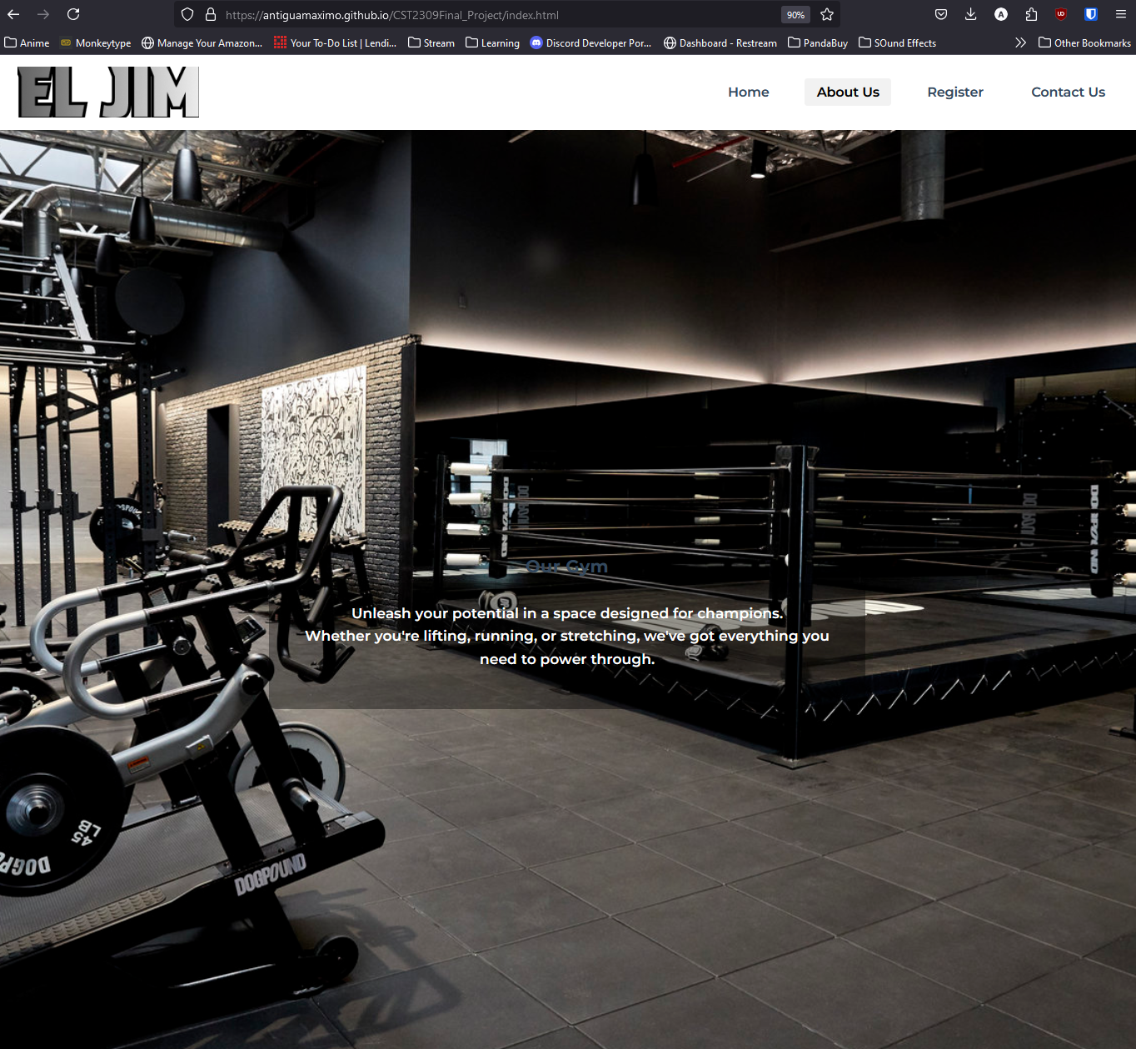

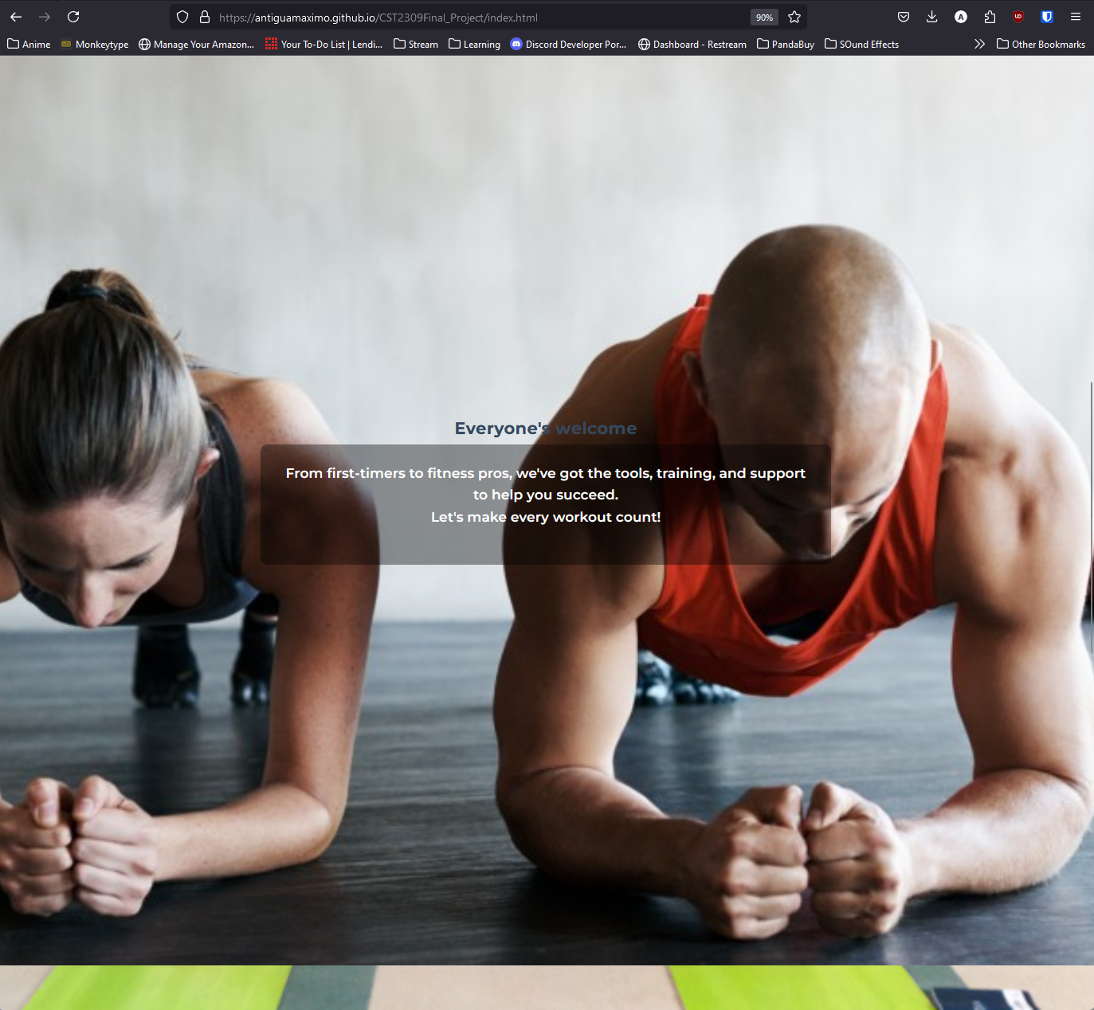

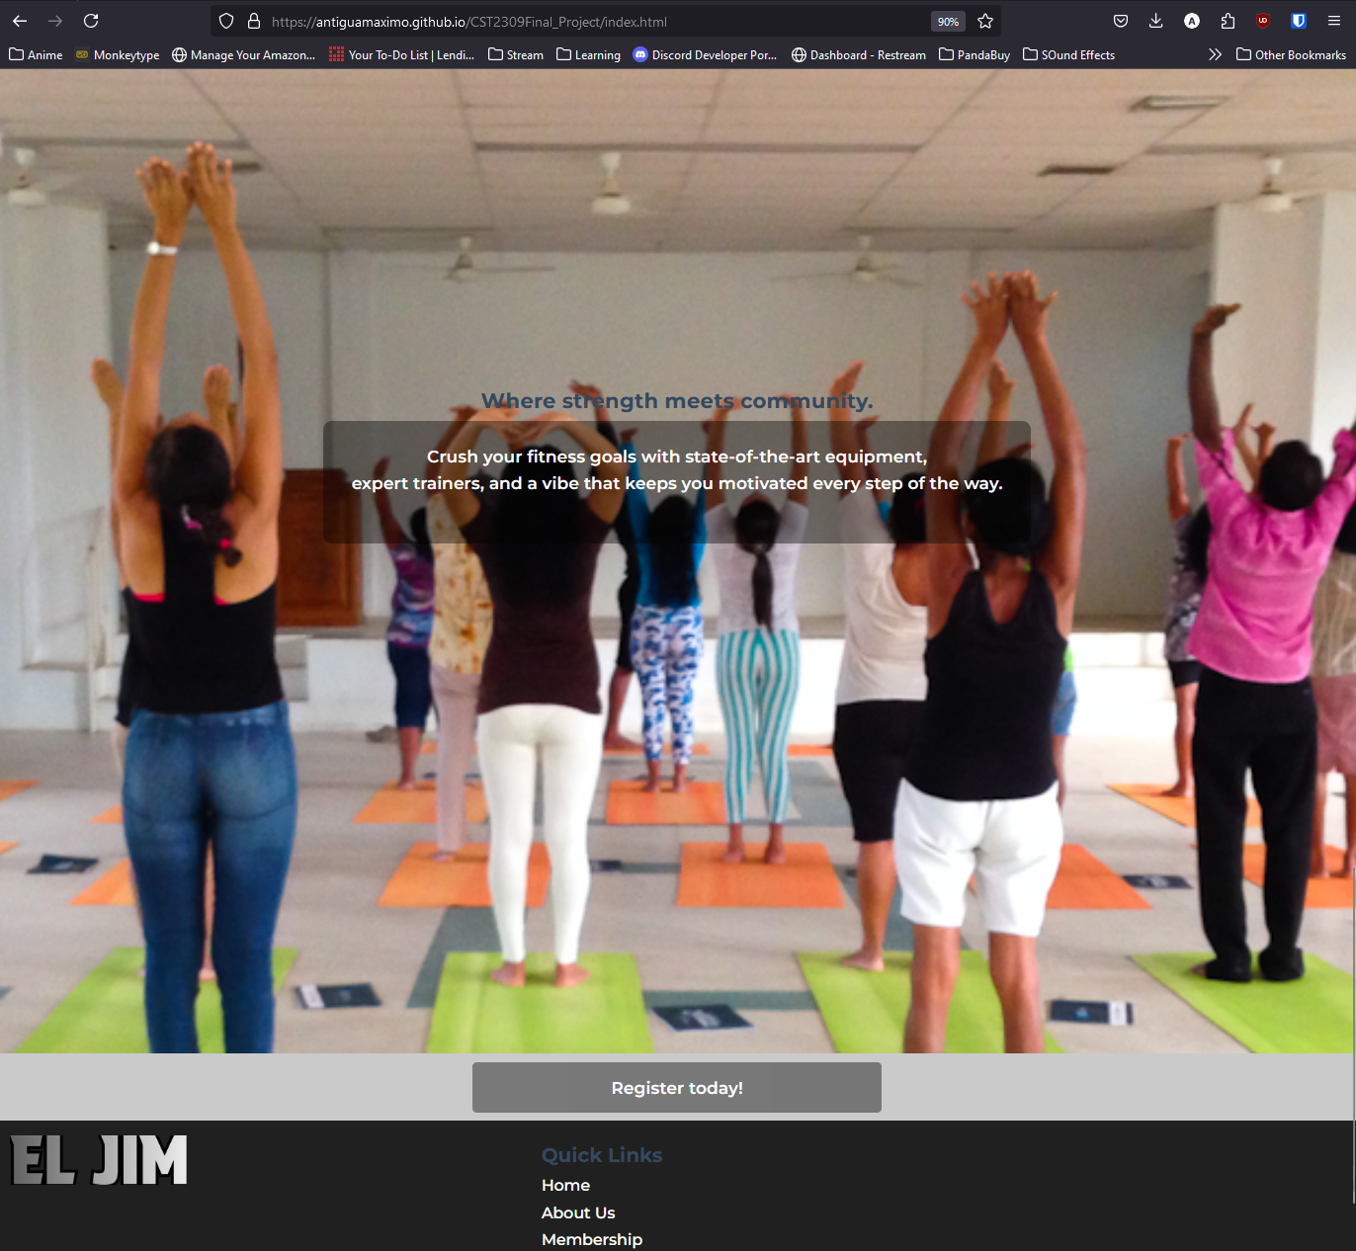

1. Add screenshot of **Page 2 Membership Page** displayed in browser

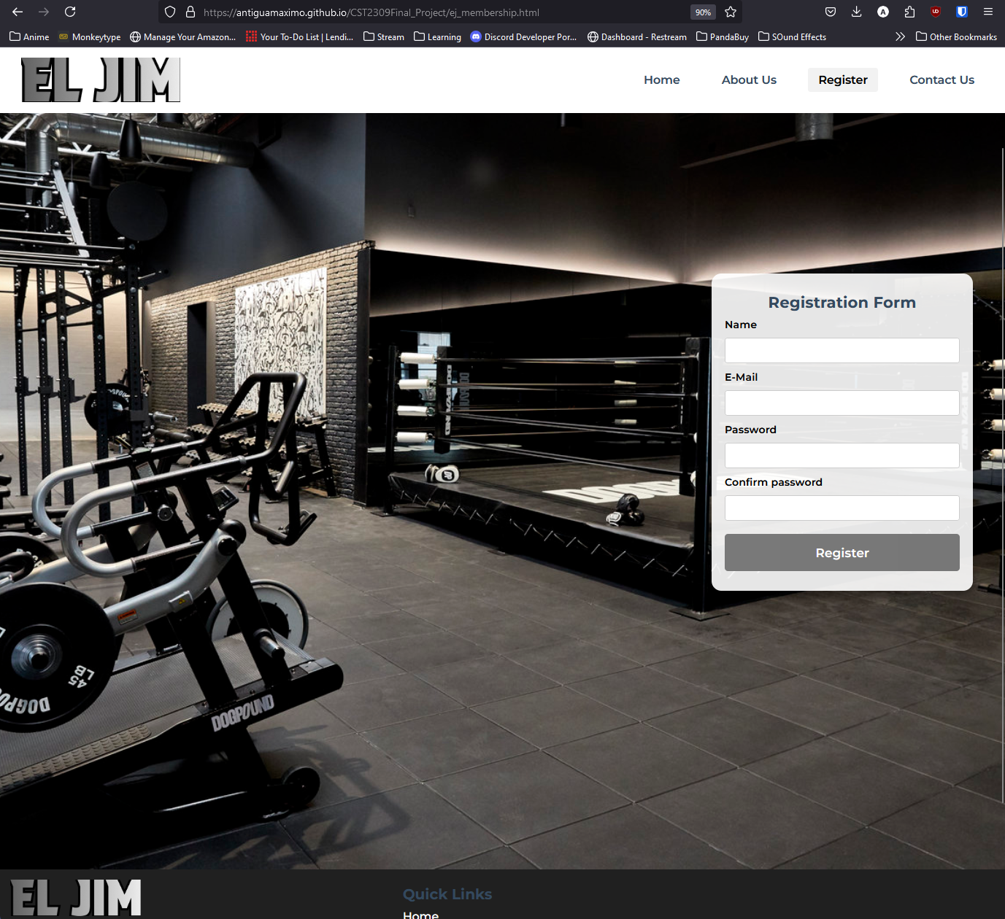

1. Add screenshots showing **validation of completed Page 2 Membership Page** displayed in browser from the Markup Validation Service at <https://validator.w3.org/>

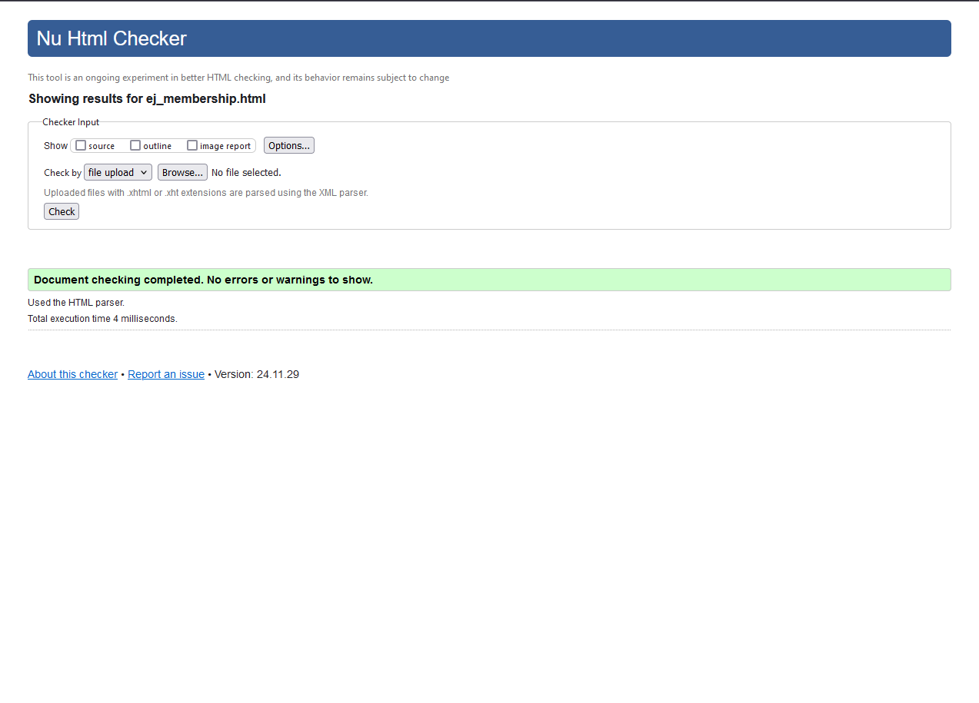

1. Add screenshot showing **Page 3** ( Display Your creativity **)** displayed in browser

Slider

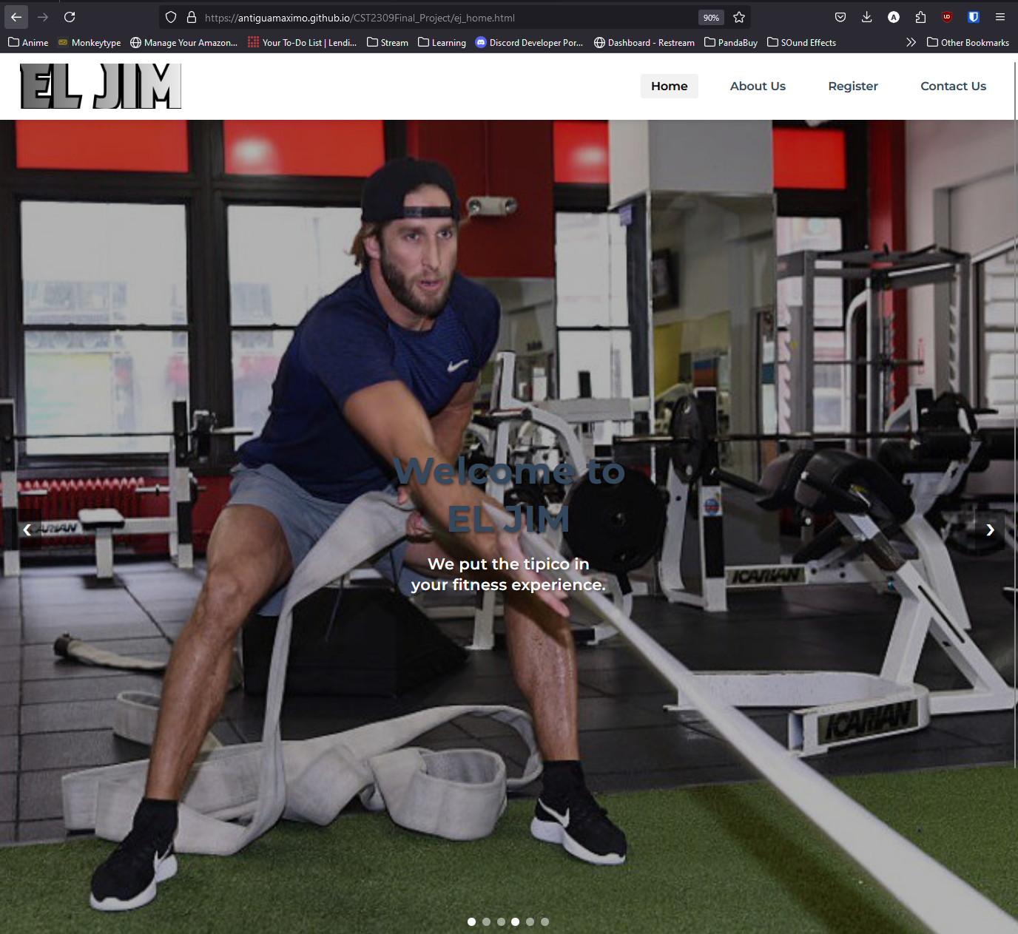

Contact Us

